## What Caused the Great Depression?

A young man in a federal work program was interviewed in Birmingham, Alabama, in 1934: "For a few weeks it isn't so bad for a man and his wife and a baby to get along on $4.80 a week, paying $3 of it out for rent. But when it runs into months - and you can't see anything better ahead - you get damned discouraged."

In Chicago, elevated train riders reported seeing men and women searching for scraps of food in garbage cans and refuse piles behind restaurants.

A western rancher explained that he had just killed 3000 sheep and thrown them down a canyon, because it cost $1.10 to ship a sheep to market, and then he couldn't sell it for even a dollar.

On a cold mountain morning in the early 1930s, a young Appalachian school girl did not look well. Her teacher approached her desk and urged her to go home and get some food in her system. "I can't," said the little girl, "It's my sister's tum to eat."

This was the underside of America in the 1930s. Not everyone was in such desperate straits, but millions were. Was this the same America that a few short years before had been filled with Yankee baseball, soaring stock prices, and the promise of a Ford in every garage? What happened to those Roaring Twenties? What had gone wrong?

What caused the Great Depression is basically an economic question. For years economists and economic historians have looked for the answers. There is general agreement that the Depression resulted from several causes, not just one.

However, the argument takes place over which cause or causes are most important. In this DBQ you are asked to join the debate. In preparation, let's do a little **Economics 101.** We will cover four basic ideas.

One of the most fundamental concepts in economics is the **law of supply and demand.** This law says that if the supply of goods increases, and if consumer demand stays the same, then prices will drop. Or, if consumer demand increases, say for Nike shoes, and supply remains the same, then prices will ?

(You're right, go up.) One of the happy results of this thinking is that you will never produce too many goods. If you manufacture more Nikes than people will buy at $80, well, just lower the price and demand will take care of your surplus.

Another theory, **Say's Law,** predicts that surplus will always disappear because prices will come down until everything gets bought. Most economists and politicians in the 1920s firmly believed this. Government action wasn't neces­ sary to make things better. The law of supply and demand and Say's Law would take care of everything.



0

First commercial

radio broadcast

.*t*

2,080,00

unemployed

Babe Ruth hits 60 home runs

I

in US

"Star-spangled Banner" becomes official

US a tllem

Franklin Roosevelt

becomes president

Stock market crash; Martin Luther King Jr. is born

12,060,000

unemployed in US

Japan bombs Pearl Harbor

1920 1927

I I I

1928 1929 1931 **1932 1933 1941**

A third idea in economics is the **business cycle.** It works hand in hand with supply and demand. The business cycle is best explained with the help of a picture. You will first notice that it isn't really a cycle; it's more like a roller



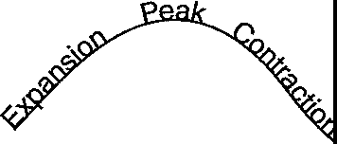

coaster. How does it work? Let's pick a **trough** for a starting point. An economic trough is a low point. If it is a very low point we call it a **reces­ sion.** If it is a very, *very* low point we call it a **depression.** It is always a time when more peo­ ple than usual are out of work. These unem­ ployed workers are quite broke and only buying the bare essentials.

Now, according to standard economic thinking in the 1920s, troughs will disappear when prices get so low that even the poor begin to buy. Middle-class buyers who might have been a bit cautious during the downturn (could they, too, lose their jobs?) see the economy picking up and decide to buy that new car after all. Such buying gets the economic engine started again. This is called **recovery.** Plants hire back workers to meet new orders; the new workers get paid and go out and buy their own new car, or refrigerator, or fancy dress. This further stimulates production, and the economy enters a full-blown period of **expansion.**

Housing starts increase; stocks go up; happy days are here again!

But the business cycle has a built-in - some would say necessary - downside. People get "stuffed" with stuff. They have their car, or two cars, their house, their new furniture. At this point, buying slacks off. A few workers are let go. The fired workers can't buy, and the economy goes into a slide - this is a **contraction.** More workers are fired; more workers can't buy.

Down the roller coaster goes until it reaches a

new trough where **it** rests until the economy is ready for another ride upward.

Supply and demand. Says Law. The business cycle. And now our fourth and last concept, the **stock market.** Stocks are a rather ingenious invention. They were first used in Europe about 300 years ago to solve a problem: how to raise **capital** (money) for a new business that was bigger than the entrepreneur and the partners could afford. The answer was to set up a **joint stock company.** Quite simply, this meant selling ownership shares in the new company to anyone willing to invest. Stock purchasers were really buying a piece of the business. If the business made a profit, the investors shared the profits. If it failed, the investors lost part or even all of their money.

When stocks are initially sold, the company gets the investor's money and the investor gets a certificate of partial ownership. In the 1920s, like today, most original stock buyers did not hold onto their stock certificates. They sold them, hopefully for a profit, in what is called the **secondary stock market.** This secondary market accounts for most buying and selling of stock.

An investor can make money from stock in two ways. First, companies often pay **dividends,** or earnings shares, to stock holders. Second, investors can sell their stock on the secondary market for more than they paid for it. Dividends tend to go up if the company is doing well. So do stock prices. However, there are times when stocks go up simply because buyers believe they will be able to sell the stock for more next week or next month. Purchasers look in the financial pages of the newspaper, see that Radio Corporation has gone up nine **points** (dollars) in the last week, and buy shares not even knowing if the company is actually making a profit. This is called **speculation,** and it can be dangerous.

In the spring and summer of 1929 many stocks traded on the New York Stock Exchange were hitting new highs. True, probably less than

1% (under a million) of all Americans actually owned stock, but many millions more followed the market and were buoyed up by all the hoopla. So much of how an economy is doing has to do with public confidence. When things seem to be going well, consumer confidence is high and people buy. The stock market helps to build that confidence - or, if stock prices sud­ denly fall, to weaken it. And fall they did in the autumn of 1929.

For three years, from 1929 to 1932, most of America, from day laborers to President Hoover, waited for supply to create its own demand, waited for the business cycle to run its natural course, waited for the stock market to get back on its upward course. Even the Democratic candidate for president in 1932, Franklin Roosevelt, preached the old basic remedy of waiting for the economy to fix itself.

But the trough was deep and the roller coaster appeared stuck. Once elected, Roosevelt changed his thinking. He became convinced that it was necessary for the government to intervene with

**deficit federal spending.** That is, Roosevelt planned to borrow money to start projects to get the economy rolling again. Roosevelt called for a **"New Deal"** for the American worker. In the first 100 days of his administration, an avalanche of new programs passed through the Democrat controlled Congress - some provided immediate economic relief, some provided for longer range recovery, and still other programs sought reform of problem areas like the banking system.

For eight long years Roosevelt and his New Dealers would battle the Great Depression.

Loved by many, hated by some, Roosevelt labored to move the economy forward. But it was World War II and massive military spending by the government that finally broke the Depression's back.

What follows are 16 documents - charts, cartoons, an ad, short narratives - for your examination. Use them together with this essay and your own cause and effect logic to answer the question: *What caused the Great Depression?*

#### Document A

.

Source: AmeriTrust Co., Cleveland.

## United States Business Cycle

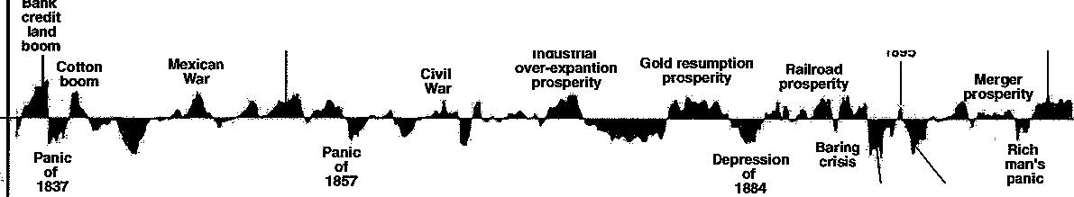

**C31ifornia gold inflation**

**prosperity period**

**Recovery** of 1895

I

**Corporate prosperity**

**Panic of 1893**

**campaign**

**depression**

**Silver**

**+60**

**+40**

**+20**

**0**

"'

**-20**

**-40**

C

**1835**

**1840 1845 1850 1855 1860 1865 1870 1875 1880 1885 1890 1895 1900 1905**

**+60**

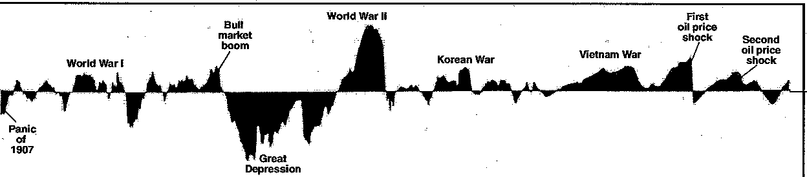

**+40**

**+20**

**0**

"

**-20**

3

**-40**

,

**-60**

*a*

**1910 1915 1920 1925 1930 1935 1940 1945 1950 1955 1960 1965**

**1970 1975 1980 1985**

#### Document B

**Source:** President Calvin Coolidge, last Annual Message to Congress, December, 1928.

No Congress of the United States ever assembled...has met with a more pleasing prospect.... The great wealth created by our enterprise and industry, and saved by . our economy, has had the widest distribution among our own people, and has gone out in a steady stream to serve the charity and the business of the world. The requirements of existence have passed beyond the standard of necessity into the region of luxury.... The country can regard the present with satisfaction and anticipate the future with optimism.

#### Document C

**Source:** John T. Raskob, former executive, General Motors; Chairman, Democratic National Commtttee. "Everybody Ought to be Rich," *Ladies Home Journal,* August, 1929.

Reprinted with the permission of *Ladies Home Journal,* Copyright (c) 1929 Meredith Corporation. All rights reserved.

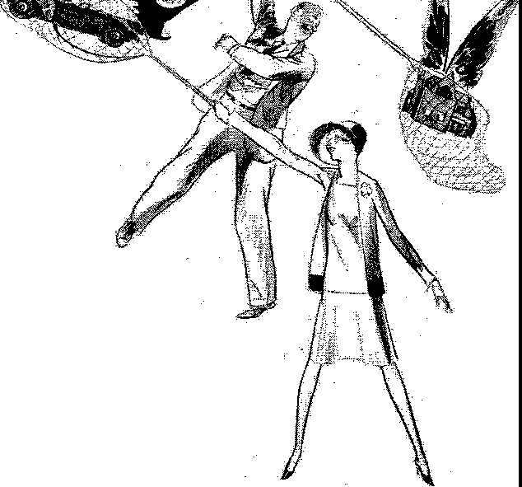Suppose a man marries at the age of twenty-three and begins a regular saving of fifteen dollars a month - and almost anyone who is employed can do that if he tries. If he invests in good common

stocks and allows the *.I*

dividends... to accumulate, he will at the. end of twenty years

have at least eighty thousand dollars

and an income from investments of around four hundred dollars a month. He will be rich. And because anyone can do that I

am firm in my belief that anyone not only can be rich but ought to be rich.

Source: *New York Times.* October 29, 1929.

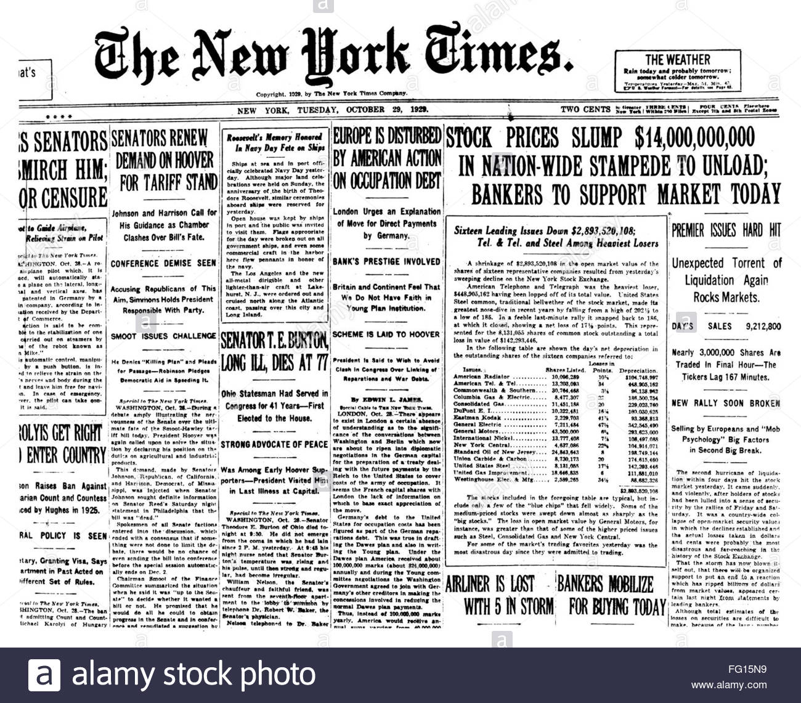

"

**Source:** Adapted from *Historical Statistics of the United States, Part 1,* 1975.

# 

**Source:** Harry J. Carman and Harold C. Syrett, *A History of the American People,* 1952.

The final development that set the stage for the collapse of American prosperity in 1929 was the speculative boom that developed with increasing intensity in the years after 1927. As more investors put their money into securities (stocks) in the hope of making a quick profit on a speculative rise in stocks, the character of the New York Stock Exchange was fundamentally altered. Instead of serving primarily as a device for the accumulation of capital of industrial enterprises, the exchange became a betting ring where people gambled on stocks **in** much the same fashion that gamblers wagered on roulette or horse races. Security prices were forced up by competitive bidding rather than by any fundamental improvement in American corporate enterprise.

#### Document G

Source: Harry J. Carman and Harold C. Syrett, *A History of the American People,* 1952.

...(L)iberal margin requirements permitted the investor to enter the market on a shoestring. By buying on margin (see note below), the investor had to pay only a fraction of the quoted price of any particular security. The additional money needed to cover the purchase was supplied by the broker, who obtained these funds from a bank with which he had deposited his customer's stock as collateral. The margin buyer was particularly vulnerable to even a small decline in stock quotations. With any decrease in security values he would have to pay the additional money to cover the corresponding decrease in his collateral. If he should be unable to supply this money - and usually he could not - the broker would be compelled to sell the stock to protect himself at the bank. Once this process had started there was always the danger that it could not be stopped. (P)rices would be further depressed, and more margin buyers would be compelled to dump more stocks on the market. The circle would then be complete, for there was no apparent way of checking this downward spiral after it had been set in motion.

**Note:** Margin refers to buying stock on credit. It was possible in the late 1920s to pay as little as 10% down for a stock purchase, borrowing the rest from the stock seller or broker. The broker in turn borrowed from a friendly bank with the bank holding the stock as collateral.

#### Document H

**Source:** William E. Leuchtenburg, *The Perils of Prosperity, 1914-1932,* 1958.

Reprinted with permission from The University of Chicago Press.

With debt no longer regarded as shameful, people bought on installment. Three out of every four radios were purchased on the installment plan, 60 per cent of all automobiles and furniture. In other words, consumers bought goods on installment at a rate faster than their income was expanding, but it was inevitable that a time would come when they would have to reduce purchases, and the cutback in buying would sap the whole economy.

**Source:** Paul Blanshard, "How to live on Forty-six Cents a Day," *The Nation,* May 15, 1929.

Reprinted by permission of *The Nation.*

**Note:** Paul Blanshard, a reporter for *The Nation,* went to Greenville, South Carolina, to interview a typical cotton mill worker. Gladys Caldwell (not her real name) met Blanshard at her four-room mill cottage. The house had three double beds, four wooden chairs, a dresser, a table, an oil cook stove, and a picture of Jesus on the wall. There was no plaster, no rugs, and no heating stove. An excerpt of the interview follows.

-

Yes, I have a husband and five children. I'm a weaver, at least I work in the weave room fillin' batt'ries. I get paid by the day....

I get up at four to start breakfast for the children. When you got five young 'uns it takes a while to dress 'em. The oldest is nine and she helps alot. The others are seven, five, four, and three. What do we have for breakfast? Well, we usually have bread and butter and syrup We get a gal­

lon of butter milk every day from Mrs. Rochester for twenty-five cents....

After I've got the children dressed and fed I take 'em to the mill nursery, that is, three of 'em. Two go to school, but after school they go to the nursery until I get home from the mill. The mill don't charge anythin' to keep the children there. I could­ n't afford it....

My husband and I go to the mill at seven. He's a stripper in the cardin' room and gets $12.85 a week. You know he's runnin' four jobs ever since they put this stretch-system on him and he ain't gettin' any more than he used to get for one.

Where'd they put the other three men? Why they laid 'em off and they gave him the same $12.85 he got before.

I work in the weavin' room and I get

$1.80 a day. That's $9.95 a week for five and a half days. I work from seven to six with an hour for dinner At noon I run

home and get dinner for the seven of us. The

children come home from school and the nursery. We have more to eat at noon. We have beans and baked sweets (potatoes) and bread and butter, and sometimes fat-back (fat bacon) and sometimes pie, ifl get time to make it. Of course I make my own bread.

It takes about $16 a week to feed us. We get nearly all of it at the company store with jay flaps. They are the slips the company gives you for buying groceries with after you've worked all day.

When the whistle blows at six I come home and get supper. When supper is over I have a chance to make the children's clothes. Yes, I make 'em all, and all my own clothes, too. I never buy a dress at a store....

I send the washin' to the laundry. It costs nearly two dollars a week. I just couldn't do that, too. Our rent in this house is only $1.30 a week....

I rode around right smart when I was single, but I ain't been on a train more than once a year since. My husband reads a book once in a while but I don't get time. I went through the third grade in school and then I went to work in the mill. I was nine years old when I started work at Number 4 in Pelzer.

Maybe my children ought to get away from the mill village, but if they went any­ where they would go back to the farm and there ain't no use doin' that. The farmers haven't got it as good as we have.

Source: *Fortune,* Februaiy, 1930.

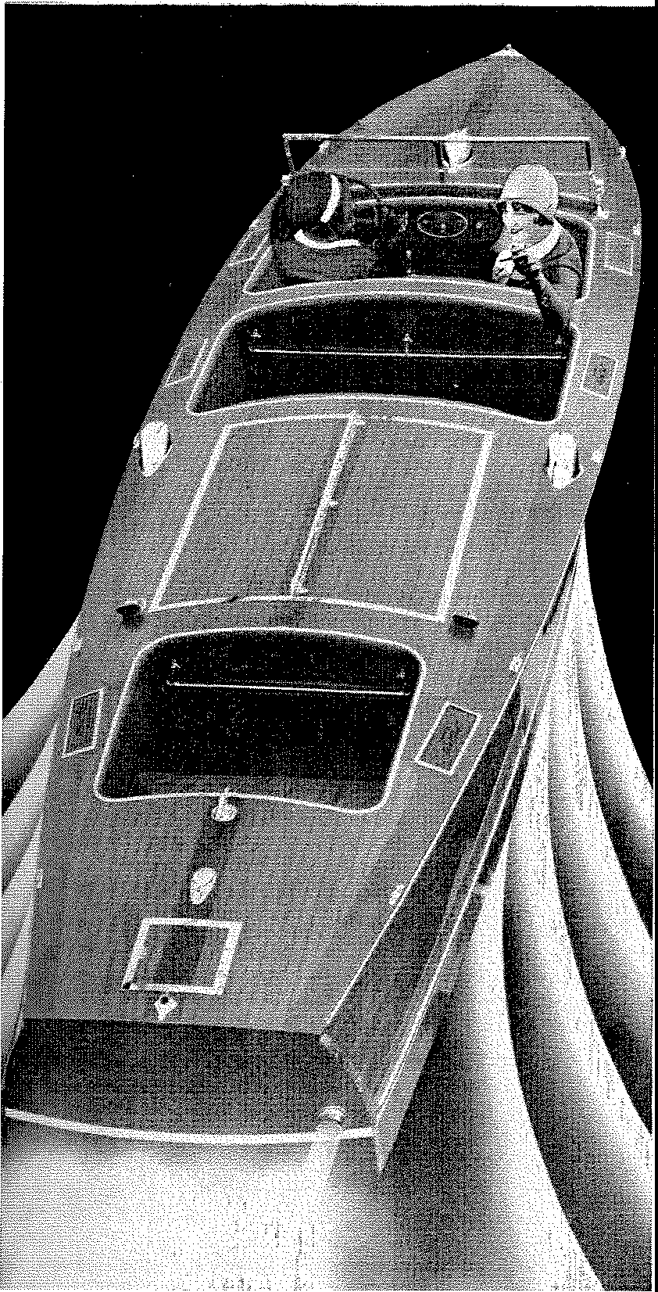UILT by Gar Wood-by the same craftsmen who build the Miss Americas, year after year the fastest

-

B

boats of their time!

How superfluous to say any­ thing more about Gar Wood runabouts.

Yet, you may be interested in knowing, as a shrewd inves­ tor, that these stock runa­ bouts that Gar Wood builds are put together of the same identical materials and with the same care and skill as are the Gar Wood custom boats.

One man pays $35,000 for a boat, another $10,000. One has a special design, the other a stock model. Yet each is as fine a craft as the finest materials and the best skill can produce.

And if you have seen the new l930 models at the Motor Boat Show, you know how graceful, how modern, how versatile they are. If not, permit us to send you the detailed information on the softest- riding speed boat ever built.

**Source:** Table constructed from data in Frederick Lewis Allen, *The Big Change,* 1952.

# 

**Note:** In 1929, *a* $2000 income was considered the minimum necessary for meeting basic needs of the average US family. It marked the poverty line.

**Note:** In 1929, the wealthiest 5% of the US population received about 33% of the nation's personal income. In 1948, the wealthiest 5% received less than 20%. (Galbraith,*The Great Crash,* pp. 197-198.)

#### Document L

**Source:** John Kenneth Galbratth, *The Great Crash,* 1954.

Reprinted by permission of Houghton Mifflin Co. Copyright (c) 1954, 1955, 1961, 1972, 1979, 1988 by John Kenneth Galbraith. All rights reserved.

...(A)lthough the bankers were not unusually foolish in 1929, the banking structure was inherently weak. The weakness was...in the large number of independent (banks). When one bank failed, the assets of others were frozen while depositors elsewhere had a...warning to go and ask for their money. Thus one failure led to other failures, and these spread with a domino effect. When income, employment, and values fell as

the result of a depression bank failures could quickly become epidemic. This happened after 1929.... The weak destroyed not only the other weak, but weakened the strong....

Needless to say, such a banking system, once in the convulsions of failure, had a repressive effect on the spending of its depositors and the investment of its clients.

**Source:** Elmer Davis, "If Hoover Fails," *Harpers Monthly,* March, 1929.

Our prosperity is a quantity prosperity...(a)nd quantity prosperity inevitably defeats its own purpose When every family has become a two-car family, dividends

on automobile stocks can be maintained only by insisting that it must become a three-car family. In past times (w)hen people had bought all they could afford they

stopped buying; production slackened, workmen were laid off, until the manufactured surplus was used up. We, it seems, have abolished the business cycle; when people have bought all they can afford they go on buying, a little down and the rest in easy payments. But I suspect that. we have only deferred payment, not escaped it, and

that the bill will be all the larger when it finally has to be faced.

#### Document N

**Source:** *Current History,* from *St. Paul Daily News,* April, 1930.

#### The Stumbling Block

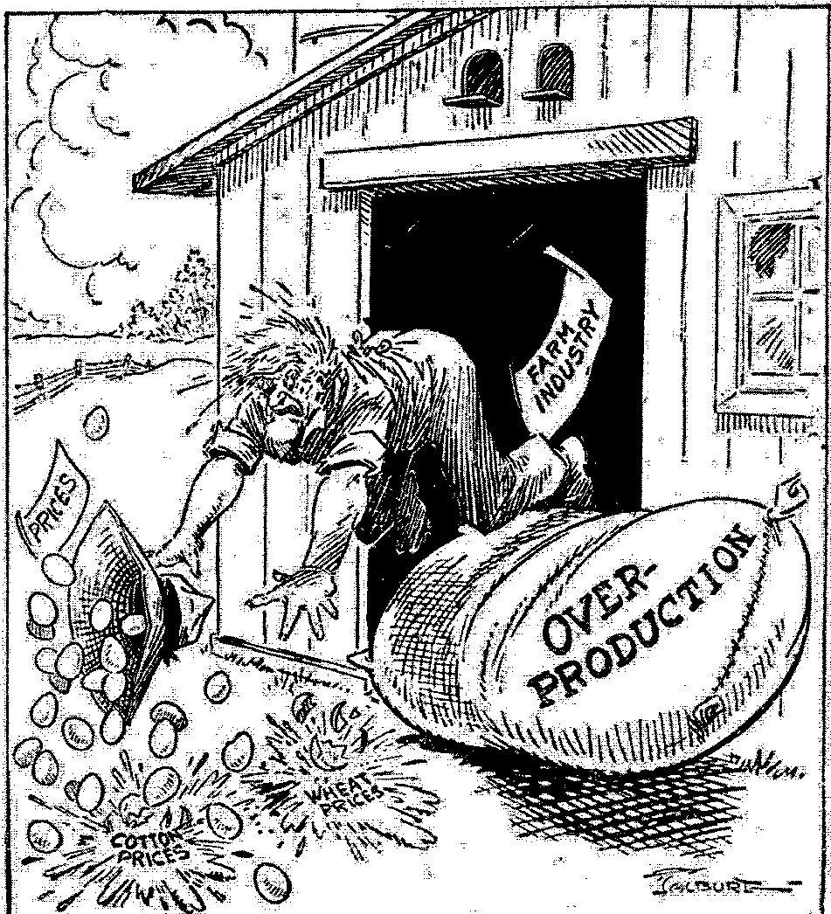

Source: Prtnted in *Current History,* August, 1930.

# 

AMERICAN TARFF POLICY

**"A mighty fortress is our gold”**_

* · *--Nebelspalter*, Zurich

### Document P

**Source:** William E. Leuchtenburg, *The Perils of Prosperity, 1914-1932,* 1958.

Reprinted with permission from The University of Chicago Press.

...The war (World War I) had produced a revolutionary change in the world economy. In 1914 the United States was a debtor nation; American citizens owed foreign investors three billion dollars. By the end of 1919, the United States was a creditor nation, with foreigners owing American investors nearly three billion dollars. In addition, the United States had loaned over ten billion dollars to foreign countries, mostly to carry on the war, in part for post war reconstruction.

...If the United States was to function as a creditor nation, it had to import more than it exported (only by selling to the US could foreign nations get the money to pay off US creditors). But the country moved in precisely the opposite direction. By an emergency tariff in 1921 and the Fordney-McCumber Tariff Act of 1922, the United States...restored the high prewar rates and added a few new high tolls of its own.

...In 1930, neomercantilism (the attempt to export more than was imported, regardless of the long-run effect) was carried as far as it could go with the adoption of the Hawley-Smoot Tariff; in the teeth of protests from thirty-four countries and over one thousand American economists, Congress stepped up tariff rates still higher. As the economists had warned, the new law throttled world trade and brought a wave of retaliation from other countries.